Assignment 1_2 (15 points)
In this assignment you will create your second Web XHTML page named CSS_Doc.html on your York Web space and you will connect it to the first page for CSE1550 on the Web site (Link1). Redo the Link 1 button, replace the text Link1 by CSS_DOC and make it a link to the CSS_Doc.html document.
CSS_Doc.html should look in Firefox as the document in Figure 1. It must contain CSS document-level style specifications used to obtain the fonts, background color, alignment, etc. for your document. The title of the document is: Assignment 1_2 YOUR NAME. Replace YOUR NAME with your own family and given name.
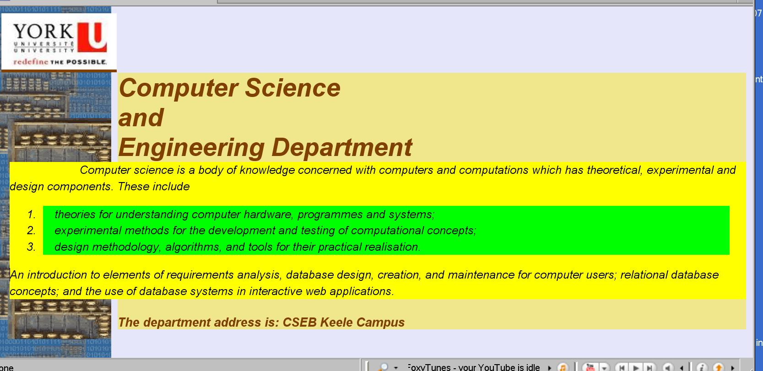
Figure 1
The ?? as value for a property below means that you have to try different values for the property and decide which one is right for your document.
You may find the image for York University at URL: http://www.cse.yorku.ca/~mkant/images/YorkU.jpg and the image on the left of the Figure 1 at URL:http://www.cse.yorku.ca/~mkant/images/computer.gif.
No use of tables admitted for this assignment.
The body of the document has the following properties:
font-style:italic
font-family:fantasy
background-image: url(??)
background-repeat:??
background-color: #E6E6FA"

The title: “Computer Science and Engineering Department” has the following properties:
font-size: 30pt
font-weight: bold
color: #804000
margin-left: ??pt
background-color:#F0E68C

The main text:” Computer science is a body……..” has the following properties:
font-size: 14pt
text-align: left
margin-left: ??pt
line-height: 1.4
color: black
text-indent: ??em
background-color: yellow
The list elements have the properties:
background-color: lime
margin-right: ??pt
text-indent: 1em
The last row (department address) has the same properties as the title except the font-size which is 15pt.
You may use also other properties if necessary.
Validate the Web page using the XHTML validator. The mark for the assignment will be 0 if the document is not XHTML valid.
Submit a cover page (Assignment 1_2) and a second page with the code of CSS_Doc.html. Use a text editor to create the pages of your assignment. Do not use a WYSWYG html editor. The mark for an assignment done with a WYSWYG editor will be 0. Use Arachnophilia or a plain text editor.

Try the all documents on your Web browser, to be sure that they are working. You will receive all points only for working documents.

